Affordable housing complex to be built near Parker Road DART Station after Plano sells land
The property is in an area the city hopes to revitalize with development.
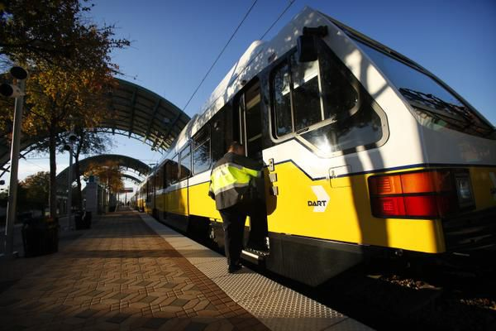
Riders are shown in this file photo at Parker Road Station in Plano. A new housing development is planned near the station. (DMN file photo)
By Teri Webster
9:52 AM on Nov 2, 2020 CST
About four-and-a-half acres of land at the northwest corner of K Avenue and Park Boulevard will be developed into mixed-income housing after the Plano City Council voted 5-3 last week to sell the city-owned property to the Plano Housing Authority for $2 million.
In June, amid a broader and long-running debate over whether to encourage high-density development in the growing suburb, the city council narrowly rejected a previous $900,000 offer on the land from the housing authority, which has proposed building a 254-unit apartment complex in a neighborhood the city hopes to revitalize.
The city subsequently put the property on the open market, and received its highest offer from the Plano Housing Authority, according to city documents.
Mayor Harry LaRosiliere and council members Maria Tu, Anthony Ricciardelli, Rick Grady and Kayci Prince voted in favor of the sale last week.
Council member Shelby Williams voted against it, along with council members Lily Bao and Rick Smith. Williams questioned whether the housing authority’s planned development would generate more property tax revenue for the city than other proposals, and argued that the $2 million would be a fraction of the total value of the land over time.
As part of the sale agreement, the Plano Housing Authority will partner with MVAH Partners and Auxano Development to build a multi-family development oriented toward the Parker Road DART rail station. The complex will have affordable and market-rate units, according to city documents.

